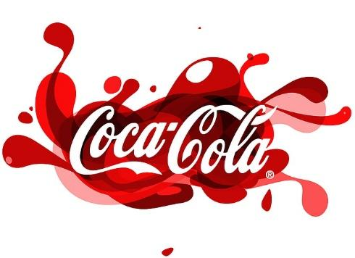

The Coca-Cola Company is a household name in the beverage industry thanks to their signature soda, Coca-Cola, which is carbonated and sweet. It was founded in Atlanta, Georgia, by John S. Pemberton in 1886, and today sells a wide variety of beverages, including Diet Coke, Sprite, and Fanta. It has a vast distribution network and operates in more than 200 nations. All people are familiar with the recognisable red and white Coca-Cola logo.

**SEGMENTATION:**

Marketsegmentation is the practice of dividing customers in to groups of potential buyers that have similar preferences and buying habits.

**Demographic**: It involves dividing market based on factors such as Age, Gender, Occupation.

1. Coke segments the small children introducing tastes like Vanilla, Lime and Cherry. They focused children from 4-12.
2. Oasis juice is made for the younger working adults, between 20-30.
3. Diet coke target adults between 30-50they are health conscious but want the taste.
4. Coco cola zero for diabetic people.
5. PowerAde sport drink and Coco cola energy for athlets.

**Psychographic**: according to this segmentation some patterns such as rate of usage, readiness to purchase. Coco cola introduce special prices with some beverages. The customers are seeking benefits are targeted.

**Geographic:** coco cola sells its products globally and target different cultures, customs, and climates. In America, it is most liked by older people too. It also varies the change accordingly, like the Asian version is sweeter than other countries.

**TARGETING:**

Coca-Cola targets multiple consumer segments simultaneously. It aims to reach a wide range of audiences, including teenagers, young adults, families, and people from various cultural backgrounds. By doing so, they can appeal to different tastes and preferences and expand their market reach.

**POSITIONING:**

Coca-Cola positions its products as refreshing, enjoyable, and associated with moments of happiness, togetherness, and celebrations. It emphasizes its heritage, global presence, and iconic branding to maintain its position as a market leader and a symbol of happiness.

The Back Story of Coca Cola (marketing strategy and planning) | T2 2016  MPK732 MARKETING MANAGEMENT (CLUSTER B)